|  |  |  |  |  |  |  |  |  |
| --- | --- | --- | --- | --- | --- | --- | --- | --- |
| |  | | --- | | HARMAN KARDON ALLURE BLUETOOTH SPEAKER | | C:\xampp\htdocs\TEMP\assets\images\products\harman-kardon-allure-voice-activated-home-speaker-with-alexa-1.jpg |  |  |  |  |  | | --- | --- | --- | --- | | C:\xampp\htdocs\TEMP\assets\images\products\harman-kardon-allure-voice-activated-home-speaker-with-alexa-1.jpg | C:\xampp\htdocs\TEMP\assets\images\products\1382-1-harman-kardon-allure.jpg | **C:\xampp\htdocs\TEMP\assets\images\products\1382-3-harman-kardon-allure.jpg** |  | |  | **Featured information**  Allure is a portable 360 surround sound desktop speaker. The speaker is equipped with 4 microphones for voice recognition. The speaker includes 3 38mm drivers and 1 sub bass driver  **Price: 200$**  **Specifications:**   * **Power capacity:** 60 W * **Bluetooth:** 4.2 * **Size:** 200 x 110 x 200 mm * **Weight:** 2,5 kg |

**Description:**

#### **Harman Kardon Allure speakers**

The Harman Kardon Allure portable speaker launched in 2017 at this year's IFA uses voice control based on Amazon Alexa, Google Assistant, Microsoft Cortana and Apple Siri.

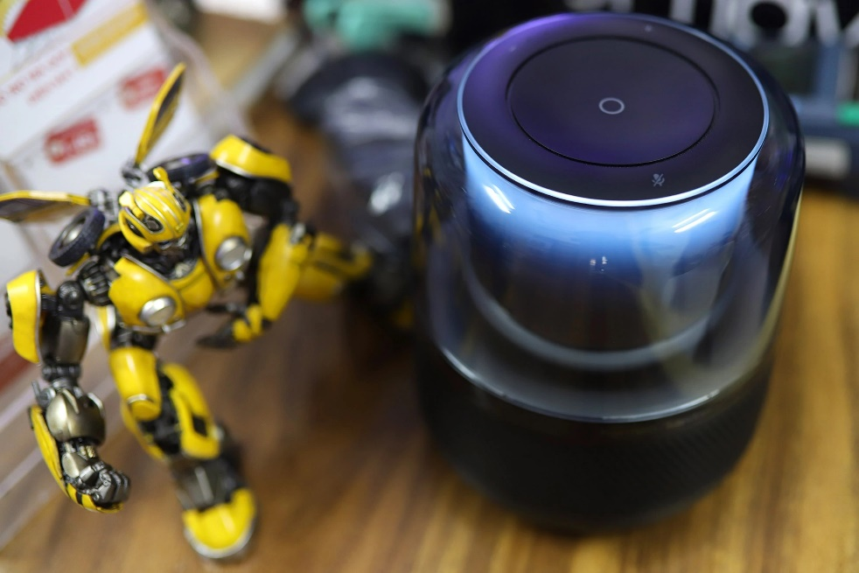

Allure 360-degree format like previous Harman speakers such as the Harman Aura 2 speaker line promises to bring Harman's signature quality and extremely good coverage of space in the room. Along with Alexa 's intelligence through voice control, it comes with extremely good sound recording capabilities, including 4 microphones with noise cancellation and sound recording functions at quite a distance; You just need to 'command' to play music, read news, control smarthome.

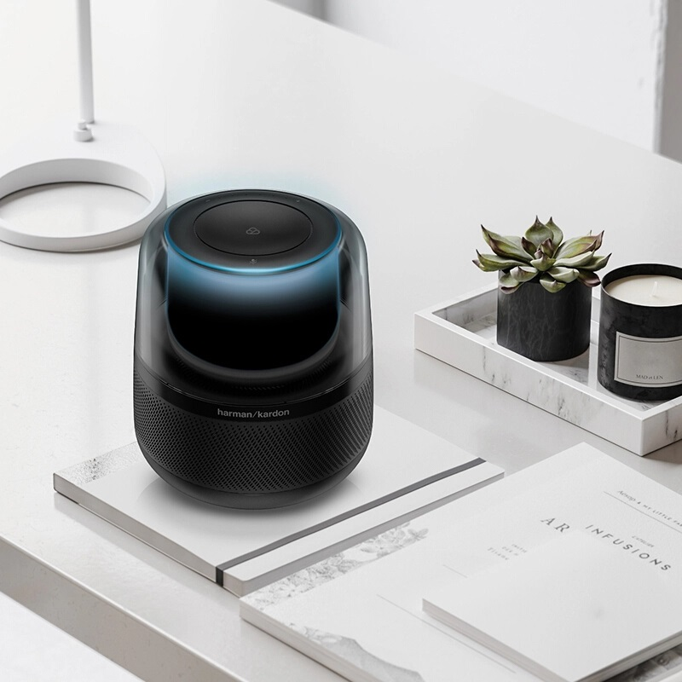

Harman Kardon Allure is also equipped with ambient lighting depending on the mode and song being played.

